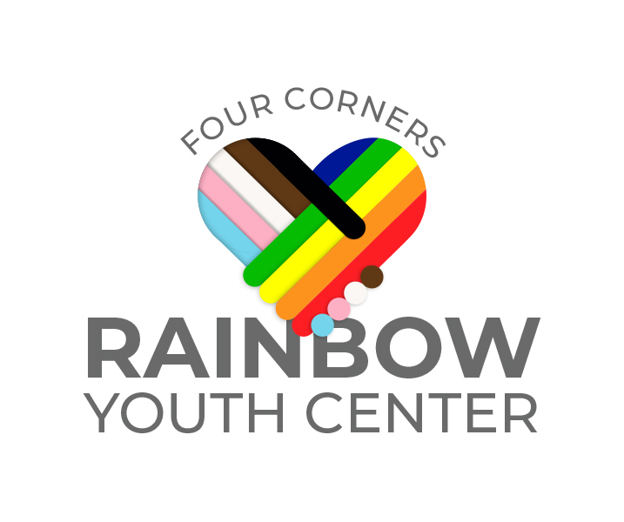
Rainbow Youth Center
Board Member Information Form

Please fill out the following and return it to the office as soon as possible. Information will be kept confidential and only used with your permission. When preparing our annotated board lists, we will limit the information on that list to your professional affiliation. For internal purposes we will prepare a board list that includes name, contact numbers including email and preferred address.

Name: ________________________________________________________

Pronouns: ______________________________________________________

Home Address: __________________________________________________

_______________________________________________________________

Home Phone: ( ) ________________

Mobile Phone: ( ) ___________________

Employer: ______________________________________________________

Title or Occupation: _______________________________________________

Office Address: __________________________________________________

_______________________________________________________________

Office Phone: ( ) ____________________ Fax: ( ) _________________

Email: Personal __________________ Office ________________________

Please indicate preferred mailing and email address by putting an *next to the appropriate entry.

Birthday: _____________________________________________________

Spouse or Partner’s Name: ______________________________________

Children and their ages/pronouns: ________________________________________

Other Boards on which you are currently serving or have previously served, dates of service:

Personal and/or professional interests relative to your organization:

Particular interests relative to RYC partnership work in the community:

Committee(s) on which you would be interested in serving (Ex: Finance, Fundraising, Policies, Program):

Other interest areas, hobbies or skills that might be interesting for us to know about and might connect with an interesting volunteer assignment:

Are you able to commit 6 hours/month to RYC as a board member volunteer?

Thank you!

